**Prediction of Online Customers’ Purchasing Intention**

Team Name: YZman

Team Member: Xiayi Ye, Chenxing Zhai

Team web page: <https://github.com/zcx10025/DM-Project>

**Abstract**

Today, the use of big data technology has penetrated into every area of our daily life, especially in the field of e-commerce. Understanding customer preferences and buying habits, predicting customer buying intentions are useful for business decisions, such as accurate delivery of advertising, network traffic analysis, market trends and etc. So we choose this topic to explore how big data technology works on prediction of online customers’ purchasing intention.

After preprocessing, exploratory data analysis and feature selection, we will build two models to predict whether a visit will end with a transaction. A comparison of the two models will also be included.

**Introduction:**

The rapid development of e-commerce is inseparable from the advancement of big data technology. Analysis of customers’ behavior, purchasing intention and their preference are useful for business decision. For example, after you buy a computer at Amazon, next time you enter Amazon, it will automatically recommend some products related to computer to you, such as keyboard, mouse and so on. After we grasp many big data technologies this semester, we have a new understanding of online shopping. So we choose this topic to explore how big data technology predict online shoppers’ purchase intention. Through this topic, we can not only understand the analysis method of e-commerce from the perspective of a consumer, but also evaluate which consumers have a strong willingness to purchase from the perspective of a merchant.

Our goal is to build two models to predict whether a visit will be finalized with a transaction with this data set. If our model is precision enough, perhaps it can really be used in reality to predict the customers’ purchasing intention. Because this will be a classification problem, so I decide to use confusion matrix to evaluate our model.

**Data set and features:**

We download the data set from UCI Machine Learning Repository. The link is : <https://archive.ics.uci.edu/ml/datasets/Online+Shoppers+Purchasing+Intention+Dataset#>

The dataset consists of 10 numerical, 8 categorical attributes and 12,330 rows. Description of them is below:

|  |  |  |
| --- | --- | --- |
| Name | Description | Type |
| Administrative | Number of administrative pages visited by the visitor | Numeric |
| Administrative Duration | Total time spent on administrative pages by the visitor | Numeric |
| Informational | Number of informational pages visited by the visitor | Numeric |
| Informational Duration | Total time spent on informational pages by the visitor | Numeric |
| Product Related | Number of product related pages visited by the visitor | Numeric |
| Product Related Duration | Total time spent on product related pages by the visitor | Numeric |
| Bounce Rate | Bounce rate of the pages visited by the visitor | Numeric |
| Exit Rate | Exit rate of the pages visited by the visitor | Numeric |
| Page Value | Value of the page visited by the visitor | Numeric |
| Special Day | Measure how close the day of the visit is to a special day | Numeric |
| Month | The day of the visit is in which month | Categorical |
| Operating System | Operating system version of the visitor | Categorical |
| Browser | Browser type of the visitor | Categorical |
| Region | Region where the visit is located | Categorical |
| Traffic Type | Ways for visitors to visit the web page | Categorical |
| Visitor Type | Whether the visitor is a new visitor, returning visitor or other | Categorical |
| Weekend | Indicate whether the day of the visit is weekend | Categorical |
| Revenue | Indicate whether this visit become a transaction finally | Categorical |

**Tools:**

We plan to use R for our project. Packages like “caret”, “ggplot2” and “corrplot” can be used to preprocess the data and do some exploration analysis. We want to build several classification model and make a prediction, so package “e1071”, “randonForest” and “neuralnet” may be included.

**Related work (Literature Review):**

[1] Yi Jin Lima, Abdullah Osmanb, Shahrul Nizam Salahuddinc, Abdul Rahim Romled, Safizal Abdullahe, 2015. Factors Influencing Online Shopping Behavior: The Mediating Role of Purchase Intention.

Available: <https://www.sciencedirect.com/science/article/pii/S2212567116000502#bibl0005>

Summary: When customers have a good impression of the product and feel that it is useful, their willingness to buy it will increase significantly. However, customers' doubts about the standardization of products on the website can adversely affect purchase behavior. In addition, if the customer subconsciously feels that the product is useful, then they do not care whether to buy online or offline. In a nutshell, the wishes of customers determine whether they will buy online.

[2] Dai, H., Wang, L., Li, Y., Nie, Z., Wen, J. R., & Zhao, L. (2010). *U.S. Patent No. 7,831,685*. Washington, DC: U.S. Patent and Trademark Office.

Available:

[https://patents.google.com/patent/US7831685B2/en](https://patents.google.com/patent/US7831685B2/en )

Summary: The data extracted from the web browser or search behavior can be used to detect users' browsing or search intent. The article mentions that machine learning can automatically detect and classify online users' business intent based on these data. Therefore, the related advertisement can be matched with the user or potential user who has the purchase intention to increase revenue.

**Preprocessing**

According to the data set, we need to change the type of the 8 categorical predictors and the output variable into factor first. Then we use the function “preProcess” to preprocess the data. Method is “range”, which means we scale the numerical predictor to a 0–1 scale. The formula is: $v^{'}=\left(\frac{v-\min_{A}}{\max_{A}-\min_{A}}\right)$.

Below is the result after we finish the preprocessing:

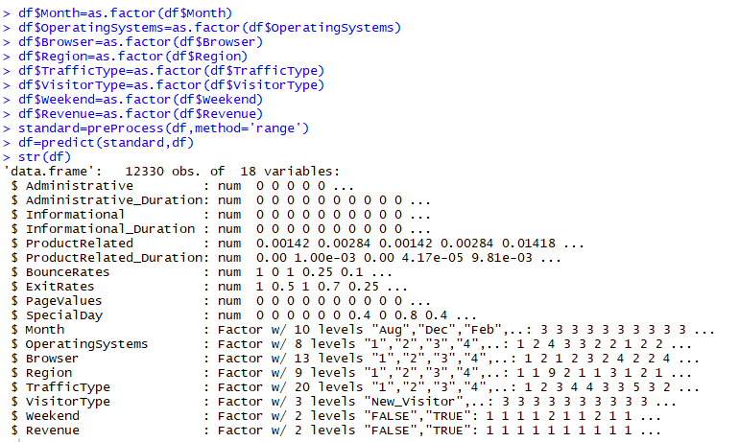

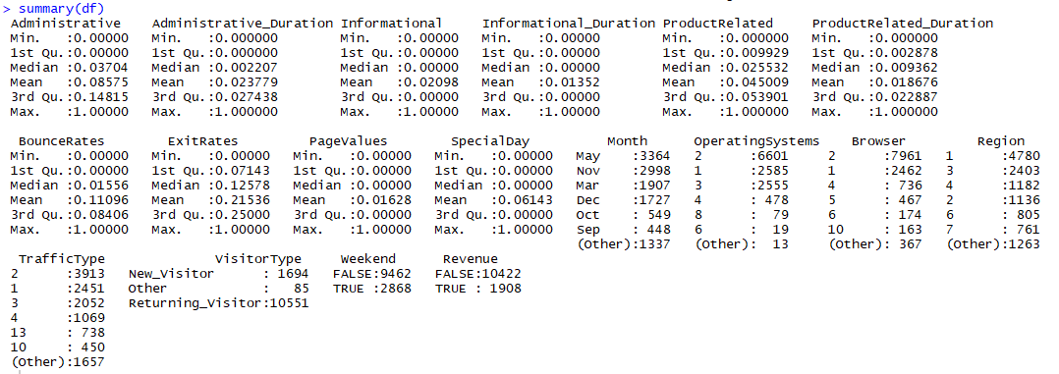

**Exploratory Data Analysis**

We created correlation coefficient graph and boxplot for the numeric variables. According to the plots below, we can say that the number of pages viewed by the user has a high correlation with the length of time spent on the page. Also we find that there are too many outliers in column “Informational_Duration” and “SpecialDay”.

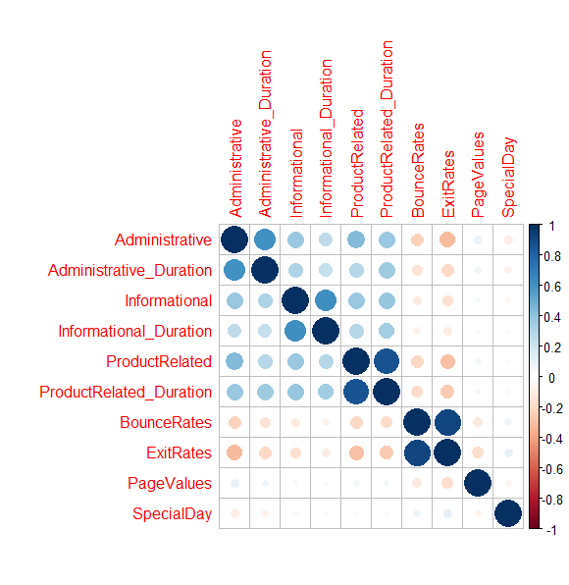

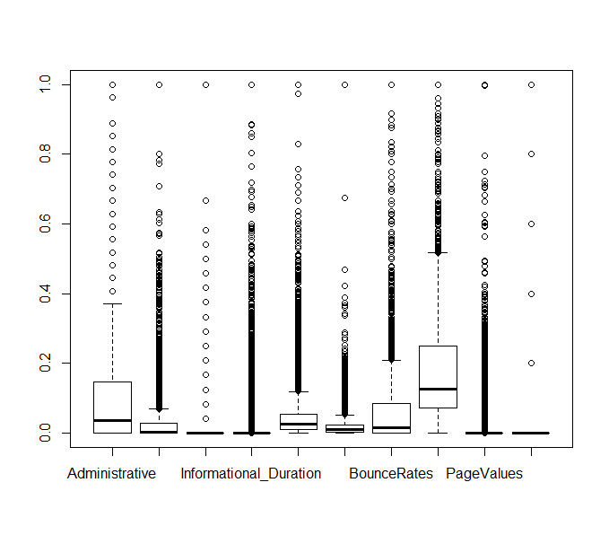

**Models**

We plan to build two models. One is based on random forest and the other is based on neural network. We will compare and analyze these three models to get their own advantages and disadvantages. So far, we have successfully established a model based on random forest. According to the confusion matrix, the accuracy is about 90%.

Before we build our first model, we use function “step” to run a feature selection. According to the result, “ProductRelated_Duration + ExitRates + PageValues + Month + TrafficType + VisitorType” is the best feature combination. So we decide to build two models based on different feature combination. One is the combination of all the features and the other is the combination obtained by function “step”. We split the data, 60% for training and 40% for testing. Then we run our model in R.

**Results and discussion**

Below is the confusion matrix of our first model:

All the features are used:

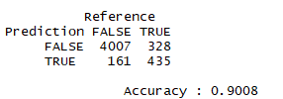

Best feature combination obtained by “step”:

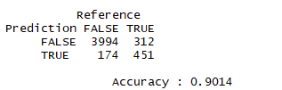

It seems that the best combination obtained by “step” is more accurate.

**Conclusions**